**Initial Zoom Call: 27/07/2023**

**Group 2 Attendees - Layefa, Harmony, Bobbie, Poppy, Maggie**

**Apps to use:**

* Trello – probably enough
* Jira
* Draw.IO
* Pygame – for making games
* Django – app/websites using python
* PyQT – desktop apps
* Tkinter – desktop apps
* Bottle – desktop apps
* WXPython
* Wireframe - for sharing ideas

**SWOT**

**Strengths:**

Bobbie -

Maggie – database, happy to give anything a go

Harmony – speaking, presentation, making things pretty

Poppy – unit testing

Layefa – figma

**Weaknesses:**

Bobbie – numbers

Maggie – unit testing

Harmony – writing code way longer than needed

Poppy – lists/dictionaries

Layefa -

**Opportunities:**

All - collaboration and creativity

**Threats:**

All - conflicting ideas

All - conflicting schedules

**Initial ideas:**

* Game – super hard but fun to do
* Some sort of app

Harmony

* Has dogs
* Always wanted to make an app for hair. People can discuss. Be more inclusive.
* Background as a carer and want to be more inclusive in every area.
* Creative

Maggie

* Something to do with travel. Solving a small problem.
* Meet up with friends in different locations. How do you find a central location to meet? Already found an API for this.

Poppy

* Recipes app.
* Finance/budgeting.
* Cats/pets

Layefa

* Budget travel or something.

**Ideas**

1. Budgeting app for kids. Gamify it? Plant that grows? Maybe the target item could fill up or complete as they save. Build a robot? If more money than item, could ask them how much left. Pocket money for chores. List they can tick off.

2. App for taking pictures of something and it tells you what it is. Some form of open AI API? Maybe an app where you take a picture of a disease and it identified the disease or takes a picture of plants and then identifies them or pictures of an animal and identifies it

**Things to consider:**

Accessibility - language option, audio access, image description

**What to do before next meeting:**

Research APIs which would work with the ideas we have come up with

**Aims for next meeting:**

Discuss any new ideas, discuss API findings, narrow down the ideas we are leaning towards

**Zoom Call: 31/07/23**

**Attendees: Maggie, Layefa. Poppy, Harmony**

Maggie - not working tomorrow morning so can look at stuff tomorrow.

Layefa:

* Social media timing app - buzz when you’ve spent a set amount of time in total.
* Positive affirmation app/screensaver.
* Kids budget app - save for my first bike app rather than a full budget app. Easier starting point.
* Kids shape identifying app - take pictures of items and a shape is identified
* Layefa - spotify list search by mood?

Harmony - not working tomorrow morning either so maybe could catch up tomorrow with Maggie. Hates the algorithm of apps when you’re sad and like something sad and it gives the same stuff. Wish it would recognise and instead recommend happy stuff.

Will also look into the shape identifying image app to see how possible that is.

For social media apps she knows how to do charts and graphs and stuff for the data to show app usage.

Set up a vote so we can decide what to do.

Like the idea of the spotify playlist idea but Layefa said she saw a video where someone had issues but he did manage to work around. Need to rewatch the video.

Will report back on whatsapp and decide on the next meeting.

Plan - have the idea pinned down by the end of the week.

**Maggie- 01/08/23**

I had a look at using the spotify API for a playlist generator app but really struggled with the authentication/request URI part of it and after a couple of hours decided to have a look at another one of our ideas which was the positive affirmation (PA) app. Spotify still a possibility if someone can work out the request URI part – will leave that for the group to decide/research further.

Did some research on how we could code the positive affirmation app and we can use the following API’s:

**ZenQuotes API:**

* can generate PA quotes for our app
* The basic use of the API does not need an authentication key but if we want to set affirmations/quotes based on mood/author etc then we need to get a key which I think would be better for our app
* Fairly easy to use

**Unsplash API**: can be used to generate images (?in the background) for our app ( Have not used this yet – read about it in ZenQuotes API documentation)

Following a youtube video and some online resources I wrote simple code and used Tkinter GUI to develop an interface. There is the possibility to also use PyQT for this.

The Tkinter GUI interface looked very basic but we can increase functionality to our app by:

* possibly having it pop up as a desktop widget or screensaver
* add a timer for pop up specific times of the day
* store quotes to a database - ?use SQL for this and link to python
* group to discuss further on increasing functionality of app if moving ahead with it

Could be more complex if we wanted to connect the app to phones as we would have to build a mobile app – too complex for Tkinter? Knowledge of mobile app development also needed.

Harmony has worked on something similar in a previous MOOC using Tkinter so can incorporate some of that knowledge into our app. Suggested adding an avatar of some sort to the front page to make it more appealing.

- Colourhunt for font colours

- Can integrate graphs somehow

- Suggests looking at similar apps to see what we want our app to do

Maggie will share basic code with the group and we’ll all feedback anything else or any more research done.

Resources: <https://youtu.be/ibf5cx221hk>

**01/08/22: Maggie and Harmony**

Maggie and I had a zoom call and discussed ideas. I showed her some of the features that could be included on our kids' shape identifying app if we went ahead with that idea. I used similar apps to help me draw a conclusion. Below shows a plant identifying app:

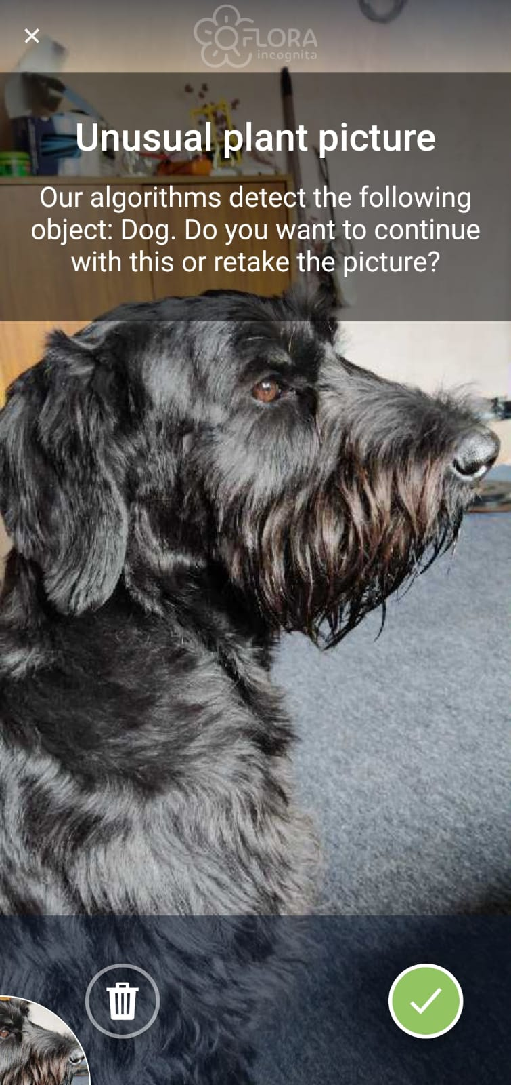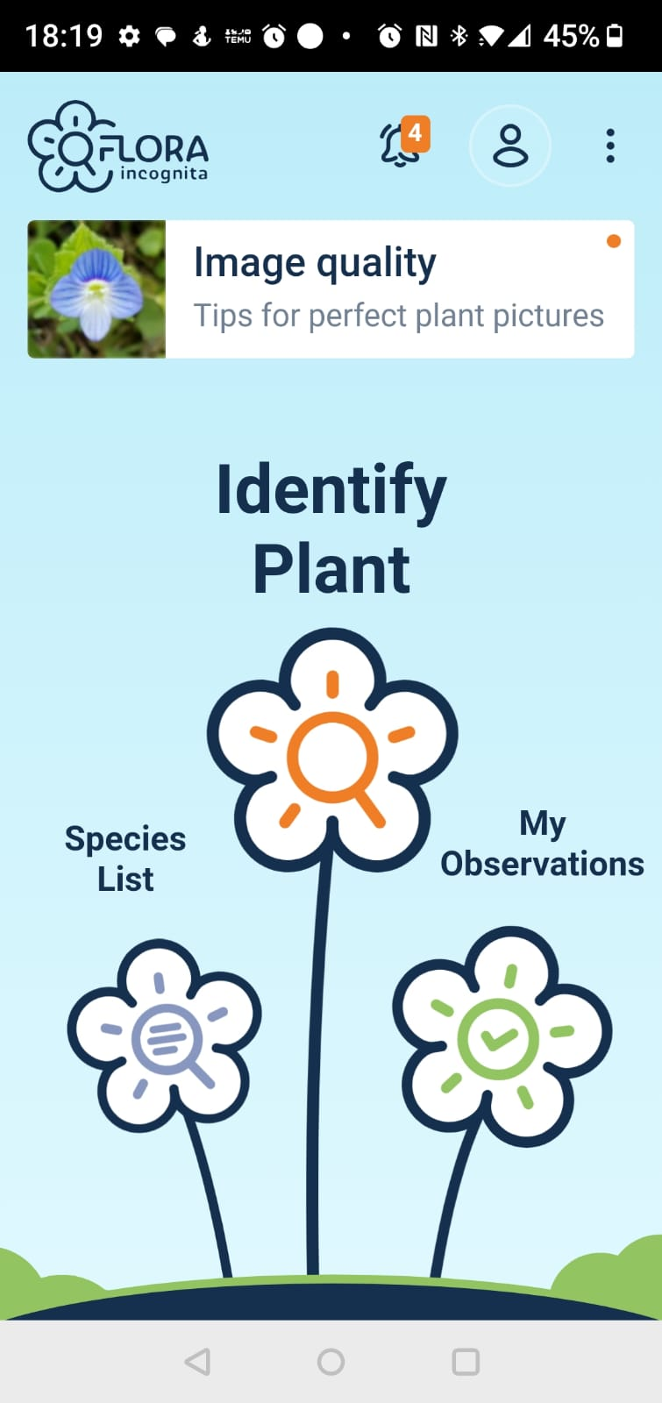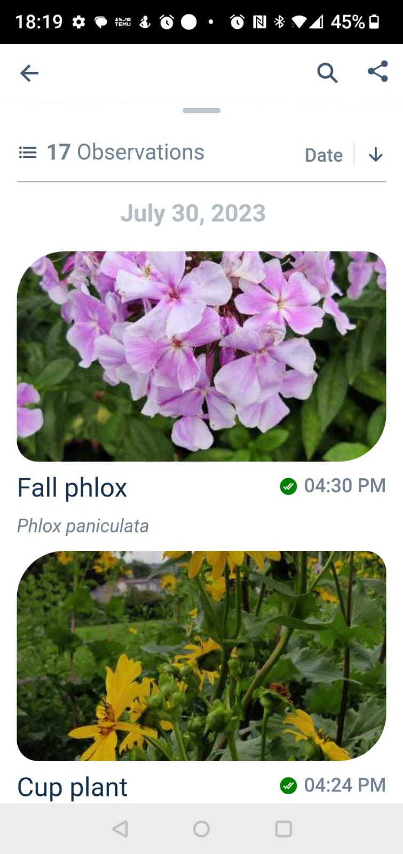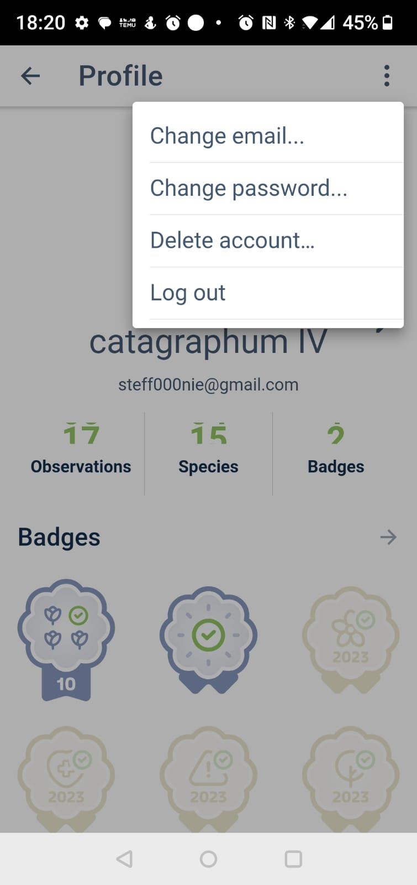

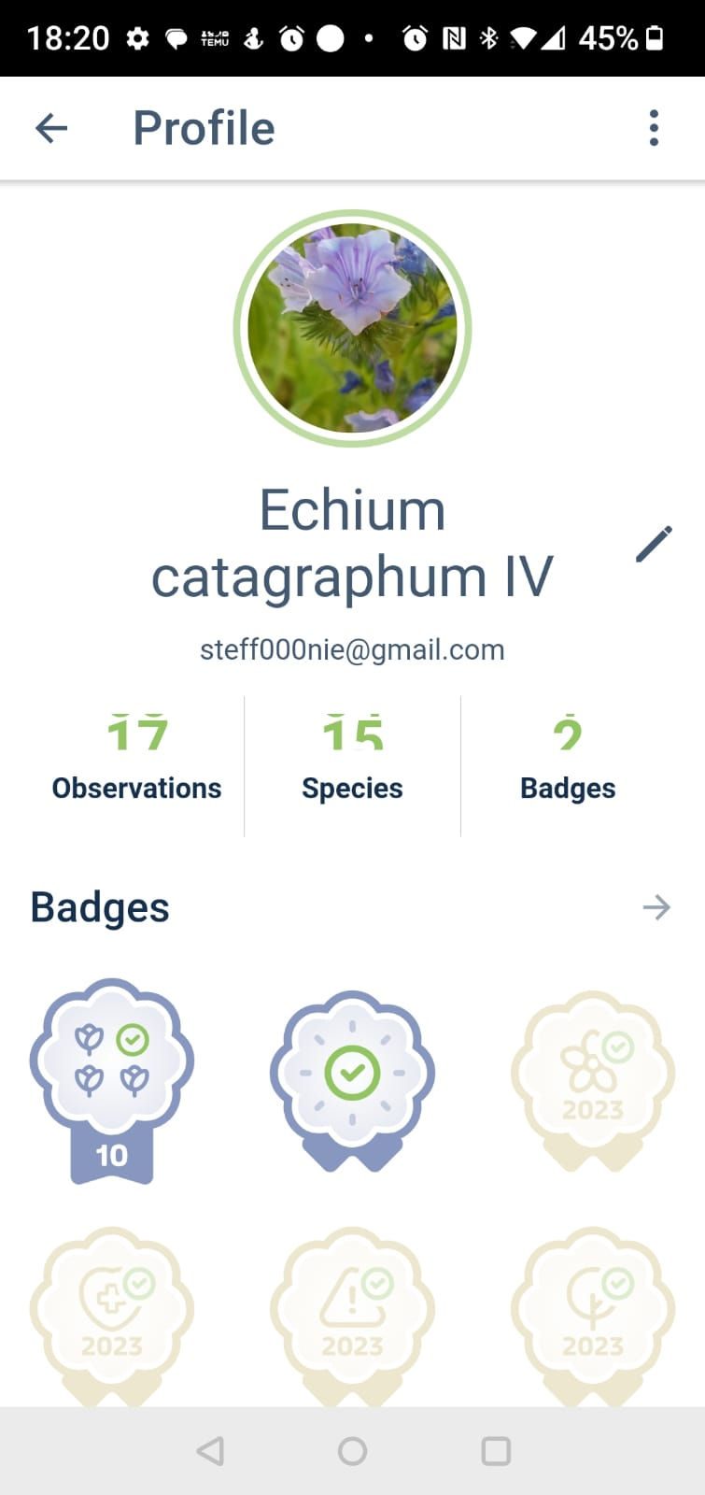

Above shows a plant identifying app. I thought some good **features for our app could include**:

* A profile (username and image)
* Access (password protected, email backup)
* SQL (somewhere to store data - images, image description, location)
* Homepage (search engine and saved data)
* Error message (as shown in the first image above, if our API was capable of also identifying what was in shot, we could try showing user messages like “Unusual shape. We cannot identify a shape in the image provided. We detect a …”)

Overall we decided that the kids shape identifying app could be too complicated to do and began to focus on the affirmations app.

Maggie made a start to an app idea on Pycharm. She created a pop up window. The window had a title and then affirmations which came from an API. A new affirmation appeared every 10 seconds. I looked over some code and suggested how we could incorporate colours to make it look prettier. Colour was added to the background using colour hut and I suggested a feature which tracked mood or a like/dislike button. Perhaps the mood or liked quote could be what goes into our SQL database and can be accessed by our user. I mentioned how when doing a mooc in machine learning we managed to plot on a graph and how this could be of use to our app if the user wanted to review quotes or track their mood - this could also be useful data for us when reviewing popular liked quotes. Maggie and I are both really happy with the affirmation app idea but will have a discussion with the rest of the group to make sure we are all in agreement

**Feature to think about**

- User input: name so that user can be welcomed personally when they enter the app

**Research**

Kivy and Beeware are great to use for creating mobile apps. Both have a basic template and access to tools. It would be easier to create an app that only works on android - iOS prefers other languages and we could encounter some issues. Kivy seems to be the easier option, it seems simpler and easier to follow. Beeware is slightly harder but has access to Toga which allows the app to be best formatted to different devices regardless of iOS/Windows/android etc

**Next meeting task:**

- Decide on app (I will send out a poll via whatsapp so we can do an internal vote)

- Discuss features we want to include

- Distribute tasks for research or trials

- Add onto the code Maggie started if we choose to do affirmation app

- Start thinking about how we can make our app accessible via phone otherwise we will have to make a desktop app

**Layefa 04/08/23:**

**Playlist Generator App idea research**

**Steps I took in trying to get an authorisation token for Spotify API.**

Install pip requests

* Created new gmail account for group to access (if needed)
* Used Gmail account to create spotify account

Spotify account details

Username: Dream team/ email: CFGGroup223@gmail.com

PW: ProjectPass1

* Borrowed JS code from “Spotify for developers” and transcribed it to Python

NOTE: I think that the first 27 lines will be useful to us. After which we should create our own functions etc

* I have shared the code with the group in slack. <https://summercfgdegree2023.slack.com/files/U057XLV4W01/F05LENR6UNQ/playlist_generator.py>
* Completed app form on spotify for developers

URI= http://127.0.0.1.8080/

Things that still need to be done.

1. Need to get spotify token/secret in order for API to work

Note: Spotify tokens expire after a period of time (1hours in most cases)

1. Find out: can token be refreshed or how to get new token

**resources**

<https://medium.com/analytics-vidhya/build-your-own-playlist-generator-with-spotifys-api-in-python-ceb883938ce4>

<https://developer.spotify.com/documentation/web-api/reference/get-recommendations>

<https://www.youtube.com/watch?v=c5sWvP9h3s8>

**Zoom call Sunday 6th August**

**Attendees: Layefa, Poppy, Maggie**

In this meeting we discuss what we’d been up to, what our findings were and how we plan to move forward. Which idea are we going with based on the time we have and our strengths.

We discussed the Spotify music playlist generator app and how we could have gone ahead with it. Poppy managed to work out the authentication/authorisation process but however after assessing the documentation and with the time constraint that we have, we decided to go ahead with the affirmations app and build on that. Although it was achievable with more time, we would have better success with the affirmations app if we focus on the minimum viable product.

We hoped to meet halfway through the week to discuss this week's homework as it is to be submitted as a group.

How we decided to distribute work:

Poppy will look into how we may be able to potentially connect it to phones, she mentioned Replit as it’s something she’s used before that could be an alternative to building a mobile phone app - Replit is similar to code pen

Layefa will look into having some other functionality such as a favourites button (for quotes that they liked) or a feedback button asking the user how it helped them or something along those lines etc. This feedback could also be stored in a DB.

Maggie will look into having a timer feature on the app for the affirmations to pop up and also see if PyQT would be an option to use as a GUI. We have looked at Tkinter thus far.

Other things we also need to think about are a database connection or graphs etc, we mentioned storing all quotes from the day as an example. For these other things we hoped that Harmony or Bobbie could look into or anyone else in the group had the capability to do it.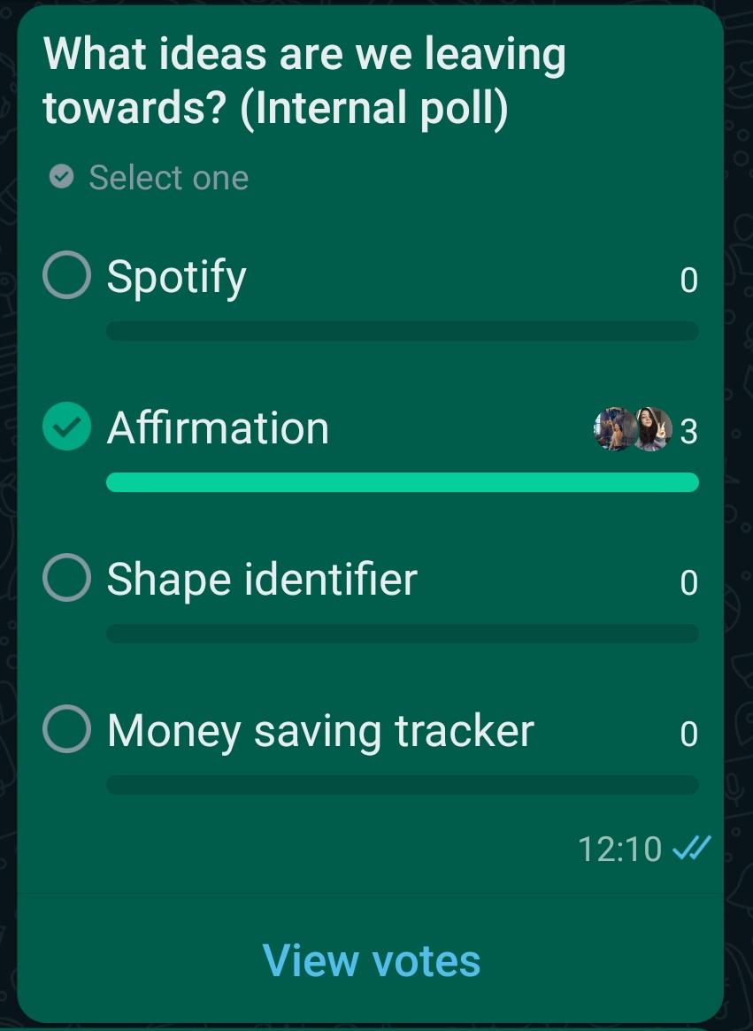

The affirmation app got the vote and we will be focusing our attention on how we can make a strong and successful app going forward

**Things to do this week**

* Layefa: look a favourite button
* Maggie: timer feature
* Poppy: look into how to connect to phone
* Harmony: create survey to send out for potential user feedback
* Look into PyQT
* Imagery and visual design UI design (user experience)
* Database
* Submission of homework

**Zoom meeting- 9/8/23**

**Attendees: Maggie, Harmony, Layefa, Poppy**

Layefa spoke about working on the favourite button feature

* What tools are we going to stick with - we’re thinking TKinter

Harmony:

* working on the diagram for the homework2
* The system diagram
* We went through the homework together
* Created a survey to gather research from our target users

We set up a github repository for the group project

Poppy to submit homework in to Luke at 3pm

**Zoom meeting- 10/8/23**

**Attendees: Maggie, Harmony, Layefa, Poppy, Bobbie**

* We discussed how to connect the code which Bobbie and Maggie Have written
* We went through the feedback from the survey with Harmony took
* Harmony mentioned another feature in regards to who would have access to feedback if it were an app for a real company.
* The mention of a name for the app
* Discussed final submission of group homework tomorrow

**Zoom Call: 13/08/23 -** Spontaneous quick call

**Attendees: Layefa, Maggie**

**Troubleshooting**

We touched base to go through each others code to see if we could spot and pull out the bugs.

Maggie was able to connect the pages together in the code

Issue with returning back to the welcome page from page 2- the emoji’s pop up on the welcome page on clicking the back button. Update: this is now fixed but in doing so an issue on the second page has appeared: the text asking the user to select an emoji based on how they feel is now behind the emoji buttons and not at the top of the page.

Layefa having issues checking if the connection to the database is working.

**Zoom Call 17/08/23**

**Attendees: Layefa, Maggie, Harmony, Poppy, Bobbie**

**Troubleshooting Issues**

* The text behind the emoji. It needs to be put above the emojis
* Click to get affirmation- tried changing the pady text- look into compound
* Storing data seems not to be working so we might leave that

Incorporate images at back or front of text

What is the name of our app?

How are we planning to conduct unit tests?

**Zoom call: Monday 21 August**

**Layefa, Poppy, Maggie, Harmony**

Maggie showed updated code to group with affirmations now appearing on the same page as ‘get affirmation button’ as opposed to a new pop-up window, only issue is affirmations also appearing on the welcome page. Added Layefa’s ‘mood’ logo to code however appears fine on first clicks to the different pages but altered when ‘back to welcome’ button’ is clicked - suggested writing a function for this instead as would like to incorporate it

To-do: Poppy will try to create an empty DB that stores favourited quotes on the click of a favourite button. Would like to have a review page for favourite quotes, time dependent

Harmony will play around with having the buttons on the front/welcome page of the app so that when clicked it goes to the requested page as opposed to having the buttons on the mood page.

We’ll decide on final colours near deadline day as that’s very simple - gender neutral colours.

Project document to be written towards the end of the week

Unit testing to be done later in the week once all code is complete

**Zoom call: Monday 21st August**

**Layefa, Poppy, Maggie, Harmony, Bobbie**

We agreed on a background colour

Harmony shared with us the code that she had been working on.

Bobbie shared how to clone the initial code and create a branch

**Zoom call: Tuesday 22nd August**

**Layefa, Poppy, Maggie, Harmony, Bobbie**

We agreed as a group to move forward with the code that Harmony started on because of its accessibility. It's easier for the user to navigate from page to page and flows better for the user experience.

We agreed to create a small powerpoint for our presentation - This will help us stay on track due to limited time.

We agreed not to make any further changes until Harmony has pushed the code.

We’re aiming to do testing on Saturday Morning.

**Things to do**

* Harmony to complete the code that she started and push it to github
* Poppy to continue on completion of of SQL and fave button
* Bobbie to continue with cloud images
* Maggie and Harmony to work on document file

**Zoom call: Thursday 24 August**

**Bobbie, Layefa, Harmony**

Harmony showed us the issue with changing the colour to the new layout

Bobbie was able to change the colour to pink- working on implementing clouds onto new code

Layefa showed presentation and discussed roles to be included onto project document

Waiting on Poppy to include sql so that the test can be run.

Harmony and Layefa wrote up project report